**Assignment 16.1**

**Using Distributed cache join the two datasets and find out the number of temperature variations in each country using map reduce?**

Driver:-

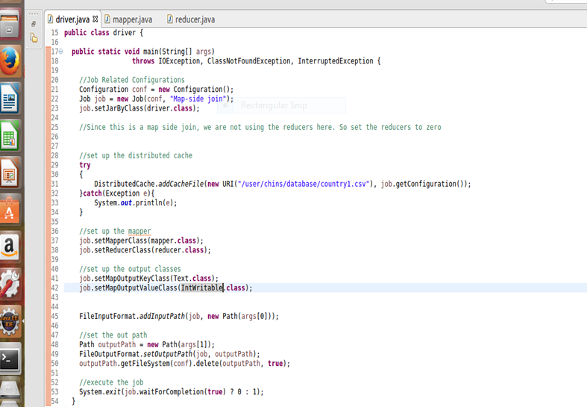

Mapper:-

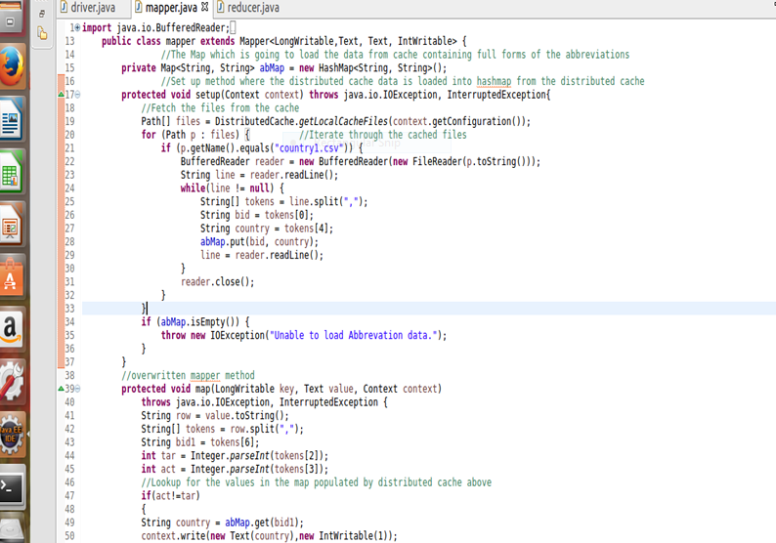

Reducer:-

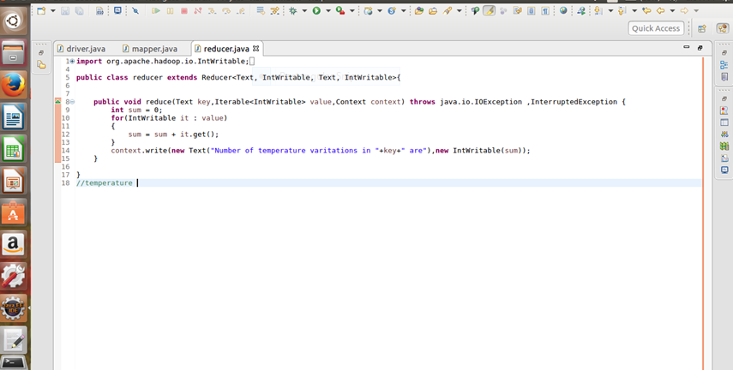

**Output**

